# **Fact Sheet: Most Concerning Issues and the COVID-19 Response**

## **Main Concerns in 2020**

Similar to previous years, the 2020 PAPI Report looked in detail at what issues citizens are most concerned about. In the context of COVID-19, it is particularly interesting to look at what effect the pandemic has had on respondents’ assessment of areas of concern, their household economic situation and their perception of the national economy’s performance.



**Figure 1: Change in Issue of Greatest Concern, 2015-2020**

As in each of the last five years, **poverty** and **hunger** remain the issues of greatest concern in 2020, mentioned by about 18 percent of respondents. However, as Figure 1 shows, there has been a substantial decline in the percentage of respondents saying they are most concerned about poverty and hunger, and this is the lowest number of respondents since 2015 to highlight these areas as their primary concerns. On the other hand, short-term economic worries emerged, with economic growth and employment two of the top-four concerns in 2020. Concerns around **health** and health insurance also soared, from around 2 percent in 2019 to 17 percent in 2020.

The 2020 increase in concern about **economic growth** is echoed by findings from other PAPI indicators. For example, PAPI asks citizens to evaluate their own **household economic conditions**. Since 2011 there has been an overall decline in those saying that their household economic situation is poor, and a steady increase in those saying their household economic situation is good. However, for the first time in 10 years that trend reversed in 2020. More respondents reported that their household economic situation was poor or very poor, while fewer respondents reported that their situation was good or very good. Similarly, there has been an increase from 14 to 18 percent of respondents who said their household economic situation worsened in 2020, compared to the last three years. Citizen confidence also shifted, with a record high proportion saying that the national economic situation was bad.

## **COVID-19: Job Losses**

To follow up on the large share of citizens concerned about their household economy, the 2020 PAPI Report looks at the job losses reported by respondents.

Job losses were widespread across the country, with an average of 25 percent of respondents reporting that they or their family members lost jobs due to COVID-19. The losses were most severe in the central and north central coastal regions. Provinces such as Da Nang, Thua Thien-Hue and Quang Binh were hit especially hard, with reported job loss rates of more than 45 percent. These provinces were also badly affected by the second wave of COVID-19 that first hit Da Nang in July 2020. In terms of income losses, the numbers were far higher. An average of 65 percent of households reported losing at least some income due to COVID-19. Again, the numbers were the highest in several central and north central coastal provinces, where more than 85 percent of respondents reported income losses. Provinces that avoided a severe COVID-19 impact on jobs and incomes were largely located in the north, near the border with China.

## **COVID-19: Government Response and Citizen Compliance**

The arrival of the COVID-19 pandemic and Viet Nam’s effective containment of the crisis was the topical issue in 2020. Other research findings suggest that Viet Nam’s successful response to date is connected to the country’s efforts in opening up for participatory governance over the past decade. Theoretically, good governance and participation are expected to drive trust, support and engagement from citizens, which in return increases compliance with laws and regulations.

The 2020 PAPI Report explores these issues. The report looks at whether good governance, as measured by PAPI, led to increased compliance with government protocols. This includes a statistical analysis of the PAPI dimensions that might contribute to compliance. In theory, good local government performance in five PAPI dimensions could play a role by increasing citizen confidence in local governments. This includes the dimensions on Participation at Local Levels (Dimension 1), Transparency (Dimension 2), Vertical Accountability (Dimension 3), Control of Corruption (Dimension 4) and E-Governance (Dimension 8).

The analysis, while suggestive, indicates that three dimensions have a positive impact on citizen willingness to comply. As shown in Figure 2, a one-point increase in Dimension 2 score leads to about a 1.2 percent greater willingness to comply. For Dimension 4, a one-point increase in the score led to a 1.5 percent increase in the willingness to comply. The dimension with the largest impact is Dimension 1: Participation at Local Levels. A one-point increase in this dimension’s aggregate score leads to a 3.1 percent greater willingness to comply from citizens. This suggests that improvements in governance, particularly controlling corruption, lead to greater compliance with government measures.

**Figure 2: Correlation between 2019 PAPI Dimensional Scores and Compliance with April 2020 Lockdown**

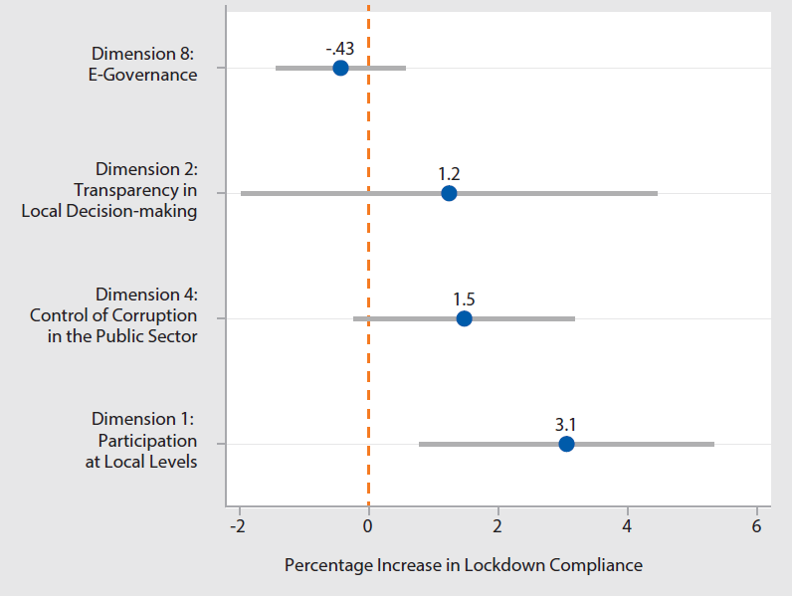

In other words, governance improvements may be a key component in increasing trust in local government, and there is a correlation between the quality of governance and compliance. This suggests that moving forward, improving governance will not only help Viet Nam’s economic development, but also will prove vital in case of unexpected emergency situations similar to COVID-19.

|  |
| --- |
| *The Vietnam Provincial Governance and Public Administration Performance Index (PAPI) is a policy monitoring tool that assesses citizen experiences and satisfaction with government performance at the national and sub-national levels in governance, public administration and public service delivery. Following the initial pilot in 2009 and a larger survey in 2010, the PAPI survey has been implemented nationwide each year since 2011. For the 2020 PAPI Report, 14,732 randomly selected citizens were surveyed. In total, 146,233 Vietnamese citizens nationwide have been directly interviewed for PAPI since 2009.*  *PAPI measures eight dimensions: participation at local levels, transparency, vertical accountability, control of corruption, public administrative procedures, public service delivery, environmental governance and e-government.*  *PAPI is the result of collaboration between the Centre for Community Support and Development Studies (CECODES), the Centre for Research and Training of the Viet Nam Fatherland Front (VFF-CRT), Real-Time Analytics and the United Nations Development Programme (UNDP).*  *During its 12 years of existence, PAPI has been generously funded by the Government of Spain from 2009 to 2010; the Swiss Agency for Cooperation and Development (SDC) from 2011 to 2017; the Department of Foreign Affairs and Trade (DFAT) of Australia from 2018 to 2025; the Embassy of Ireland from 2018 to 2021; and the United Nations and UNDP in Viet Nam since 2009.*  *The full 2020 PAPI Report and more in-depth analysis of the findings are available at:* [*www.papi.org.vn*](http://www.papi.org.vn)  *Scan the QR code to download the 2020 PAPI Report to your smartphone:*  **#PAPIvn #PAPI2020**  For more information, contact:  Nguyen Viet Lan UN Communications Team Tel: (+84 4) 38 500 158 Mob: (+84) 91 4436 769 Email: nguyen.viet.lan@undp.org |