Fact Sheet: Migration and Governance

A Pilot Study
Migration is an increasingly central concern in Viet Nam, with the number of citizens moving between provinces increasing. In major industrial provinces like Binh Duong, Dong Nai and Bac Ninh, the share of migrants moving into the province is more than five times the share of those leaving the province.
The 2020 PAPI Report therefore includes a pilot study to better understand the effect of internal migration on provincial performance in governance and public administration. The study also examines migration drivers, including the role of climate change. A total of 308 non-permanent residents from the six provinces with the highest number of internal migrants (Ha Noi, Ho Chi Minh City, Bac Ninh, Da Nang, Dong Nai and Binh Duong) were surveyed for the pilot. Importantly, these responses were analyzed separately and do not affect the PAPI scores in the rest of the report.

Demographic and Governance Differences
The analysis shows clear demographic differences between migrants and permanent residents. Migrants tend to be poorer, with fewer household assets and less income than permanent residents. They are also about 11 years younger on average, are less educated and are more likely to be female. They are dramatically less connected: only 3 percent are likely to be party members, compared to 10 percent in the permanent resident sample. Thus, in addition to being outsiders, they also lack the resources to advocate for themselves in interactions with the bureaucracy.
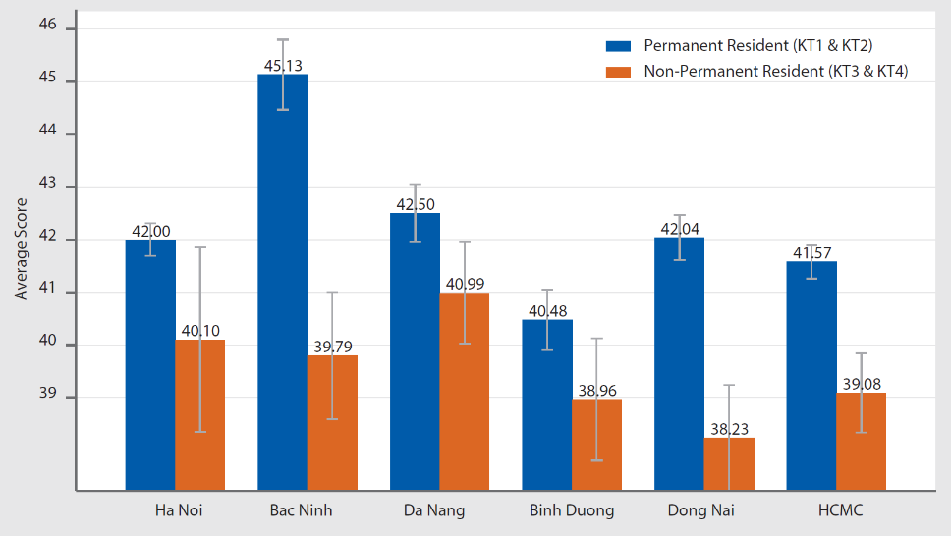
The gap in migrant experience varies heavily across provinces. As shown in Figure 1, the governance experienced by migrants in Da Nang is not much lower than that experienced by the average permanent resident. In Bac Ninh, however, there is a more than five points difference between the experience of migrants and that of permanent residents.
Figure 1: Governance gap differs by receiving provinces in 2020 PAPI
Looking at the eight PAPI dimensions, the differences between migrants and permanent residents are most pronounced in the Participation at Local Levels, Transparency in Local Decision-making, Vertical Accountability and Control of Corruption in the Public Sector dimensions. That the largest gap is in political participation makes sense, as migrants are not included in local decision-making institutions. The other scores are more surprising. Migrants seem to have significantly less access to information, are less able to file complaints or connect with local officials and are more exposed to bribe requests.

Drivers of Migration
The 2020 PAPI Report also looks at who wants to move, where to and why. Provinces in the Central Highlands and central regions have the highest percentage of respondents saying they want to move. In Dak Nong, for example, 19 percent of respondents say they want to move out of the province. By contrast, those in large urban areas express less desire to move, including residents from Can Tho and Ho Chi Minh City.
The two most preferred destinations for migrants are Ha Noi and Ho Chi Minh City, with the latter attracting 22 percent of those wanting to move. Lam Dong, Da Nang, Can Tho, Binh Duong and Dong Nai were also relatively popular, with around 4 to 6 percent of respondents choosing these provinces.
Across the country, the biggest driver of a desire to move is family reasons. Nearly half of those expressing an expectation to migrate suggested that a family reunion was the primary reason. This is followed by a desire for a better job and a better natural environment.
The pilot study also looked at how different factors impact the desire to move. This shows that younger, male Vietnamese residents—poor and wealthy alike—are the most willing to move. In particular, those who are willing to accept risks and who live in rural areas are more likely to move to urban and peri-urban areas. Having a family outside the province further increases the readiness to move, emphasizing the importance of a family network. Finally, while one’s individual income level is not the strongest determinant of the motivation to move, but the wealth of one’s province of origin is.

Impact of Climate Change on Migration
There is growing concern that climate change is going to lead to a rapid increase in migration. To assess the potential impact of climate change—and information about climate change—on the desire to migrate, the 2020 PAPI survey included a novel experiment. A subset of respondents was given different levels of information about climate risks in Viet Nam by 2050. The goal was to see how information about climate change and the possibility of a sea level rise would impact respondents’ desire to move.
The analysis shows that those who received no information about a possible sea level rise had relatively low levels of desire to migrate. When citizens are given information about climate change the percentage of those wanting to migrate jumps substantially though, rising from just under 8 percent to more than 12 percent.
The experiment also looks at the effect of a government official expressing doubt about the effects of climate change. When an official casts doubt on the scientific findings, the desire to move decreases (from 12.3 percent to 10.8 percent). However, when a map showing the areas most vulnerable to a sea level rise is also provided, this doubt from a government official no longer reduces the percentage of respondents wanting to migrate, with over 13 percent now saying they want to migrate. What this suggests is that the more concrete the information on climate change is, the less doubt there is among respondents, and their desire to migrate increases.

Key Implications
As highlighted above, there is a significant gap between migrants and permanent residents in their experience with governance. Efforts to narrow this governance gap is the equivalent of moving a province in the bottom five provinces in the country to the top five on the PAPI index. This means that migrant-receiving provinces will need to double their efforts to adequately address the needs and expectations of both permanent and non-permanent residents. More importantly, it is a high time for Viet Nam to remove the hộ khẩu status, so that every citizen can access all governance and public services equally in every province within the country.
In terms of the findings on climate change and migration, it is clear that in the absence of information, citizens may underestimate the risk of climate change, such as a sea level rise. This suggests it is important that the government provides clear information about climate change risks, so that both local leaders and citizens can appropriately assess these. Without transparent, clear information, local officials and citizens may, for example, continue to overbuild in areas vulnerable to the risks of climate change.

The Vietnam Provincial Governance and Public Administration Performance Index (PAPI) is a policy monitoring tool that assesses citizen experiences and satisfaction with government performance at the national and sub-national levels in governance, public administration and public service delivery. Following the initial pilot in 2009 and a larger survey in 2010, the PAPI survey has been implemented nationwide each year since 2011. For the 2020 PAPI Report, 14,732 randomly selected citizens were surveyed. In total, 146,233 Vietnamese citizens nationwide have been directly interviewed for PAPI since 2009.
PAPI measures eight dimensions: participation at local levels, transparency, vertical accountability, control of corruption, public administrative procedures, public service delivery, environmental governance and e-government.
PAPI is the result of collaboration between the Centre for Community Support and Development Studies (CECODES), the Centre for Research and Training of the Viet Nam Fatherland Front (VFF-CRT), Real-Time Analytics and the United Nations Development Programme (UNDP).
During its 12 years of existence, PAPI has been generously funded by the Government of Spain from 2009 to 2010; the Swiss Agency for Cooperation and Development (SDC) from 2011 to 2017; the Department of Foreign Affairs and Trade (DFAT) of Australia from 2018 to 2025; the Embassy of Ireland from 2018 to 2021; and the United Nations and UNDP in Viet Nam since 2009.
The full 2020 PAPI Report and more in-depth analysis of the findings are available at: www.papi.org.vn
Scan the QR code to download the 2020 PAPI Report to your smartphone:

For more information, contact:

Nguyen Viet Lan
UN Communications Team
Tel: (+84 4) 38 500 158
Mob: (+84) 91 4436 769
Email: nguyen.viet.lan@undp.org

#PAPIvn #PAPI2020

