Fact Sheet 2:
Migration and Governance in 2021

Migration remains an issue of key concern in Viet Nam. Disparities often encountered by growing numbers of migrants were further amplified in 2021 by the unprecedented social and economic losses left behind by COVID-19 as it swept across the country. As such, there is a critical need to identify and explore gaps in access to good governance and quality public services between migrants and permanent residents in receiving provinces as well as drivers of migration within Viet Nam in 2021, which result in wide-ranging social and economic impacts in need of agile and inclusive policy responses.
Building on PAPI’s insightful 2020 pilot survey of migrants in six selected provinces, in 2021 we widened the net to engage 1,042 non-permanent residents from the 12 provinces with the highest numbers of internal migrants to understand how internal migrants assess their host province in terms of governance performance and public service delivery.

Demographic and Governance Differences
As PAPI’s 2021 results reveal, the second year of the pandemic exacerbated governance challenges for migrants and residents in receiving provinces. Clear differences are visible between the demographics of migrants and permanent residents, with the former tending to be poorer with fewer household assets and marginally less income than residents. They are about seven years younger on average, less educated and more likely to be female. Most dramatically, they are significantly less connected, with only 3 percent likely to be Party members, compared to 10 percent in the permanent resident sample.
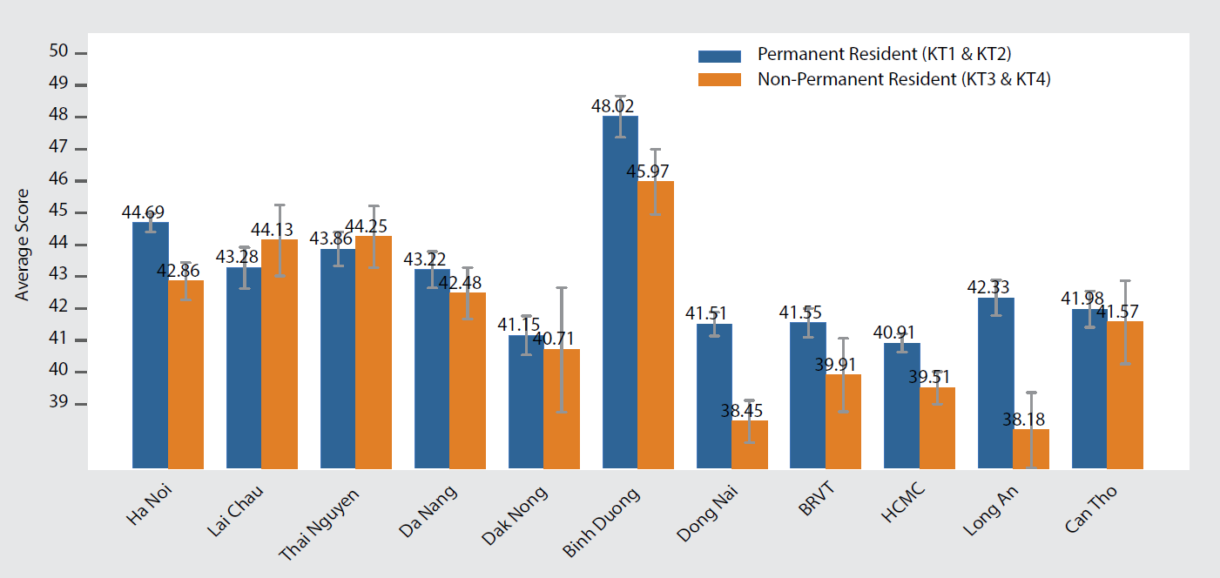
Figure 1: Governance Divide as Experienced by Immigrants in Migrant-Receiving Provinces, 2021
These demographic differences help explain why migrants’ experiences with governance appear to have degraded in the past year. Resident-migrant differences are largest in the PAPI dimensions of Participation at Local Levels and Transparency in Local Decision-making. When examining the gaps by migrant-receiving provinces – residents in Binh Duong, Dong Nai, Ha Noi and Long An – claimed more opportunities to participate at local levels and greater access to information than migrants. While residents in Long An experienced significantly fewer bribe requests and informal charges than migrant peers, the situation was reversed in Can Tho and Lai Chau.
To put these differences into perspective, if migrants were in a province on their own, they would have the second lowest PAPI ranking of all 63 provinces and the gap to catch-up with the level of governance experienced by residents would require them to leapfrog 10 other provinces. Surprisingly, however, both residents and migrants reported equal satisfaction with local governments when asked about their perception of performance. These scores may be influenced with reactions to the second year of the pandemic.

Drivers of Migration
Amid the uncertainty of the pandemic and strict lockdowns, compared to 2020’s findings, fewer residents (1.6 percent) in all provinces expressed a desire to migrate from home provinces in 2021. This is despite the sharp economic contraction in 2021 resulting in large-scale losses of income and jobs across the country. This trend also contrasts with the typical inter-provincial movement of people over the past decade as Viet Nam develops into a complex economy featuring growing concentrations of industrial activities and job opportunities.
Looking across provinces (Figure 2), Dak Nong had the highest percentage of respondents willing to move out, at 9 percent in 2021. Nevertheless, even in this Central Highlands province, the proportion of potential migrants fell by more than half of that reported in 2020. Three key reasons for wanting to move in 2021 equated to 2020’s: family reunions (to move to Ha Noi and Ho Chi Minh City), better jobs (Ho Chi Minh City, Ha Noi and Da Nang) and a better natural environment (Da Nang and Lam Dong). The top six preferred destinations in 2021 were Ho Chi Minh City, Ha Noi, Da Nang, Lam Dong, Can Tho and Binh Duong, while the least preferred were Bac Lieu, Kon Tum, Lai Chau, Lang Son and Ninh Thuan.
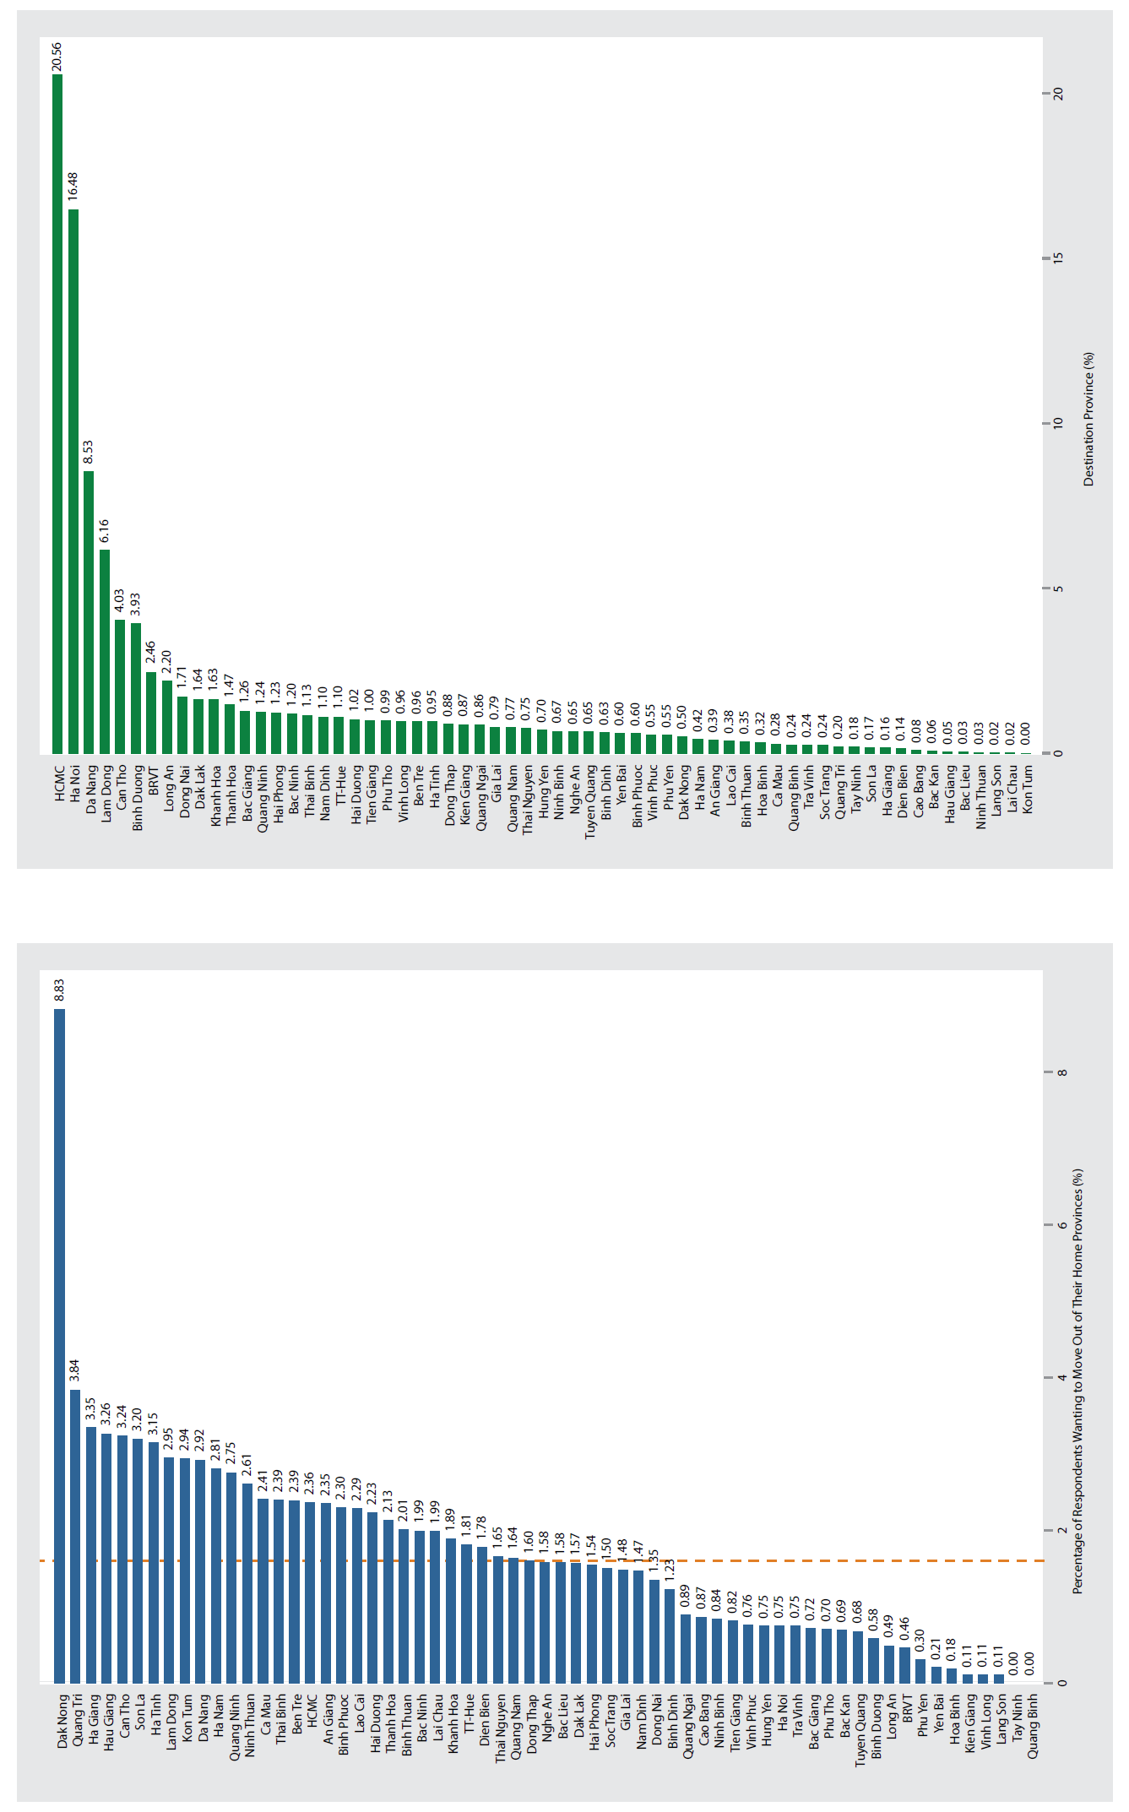
Figure 2: Provinces Where Respondents Want to Move out (Left Panel) and Provinces Where Respondents Prefer Moving to (Right Panel)

Migrants’ Willingness to Learn about Opportunities from Trade Liberalization
Typical of a rapidly developing country, featuring an increasingly dynamic economy, employment-driven internal migration is a key feature of Viet Nam’s successful growth story. This generates an important set of questions about how they learnt about those employment opportunities and their willingness to familiarize themselves with factors that might improve their economic situation and make the migration risks worthwhile.
To achieve this, in 2021 PAPI conducted a randomized experiment to answer the question of whether Viet Nam’s increasing international economic integration might influence citizens’ willingness to learn about the effects of trade liberalization on their livelihoods. We looked at whether internal migrants might respond to the European Union-Viet Nam Trade Agreement based upon the hypothesis that, on average, citizens (and particularly migrants) facing income insecurity would be more likely to take the time to understand the effects of potentially major economic changes associated with the agreement.
Strikingly, the results showed that migrants exposed to uncertainty about economic integration were significantly more likely to search for information about the economic implications of free trade than the larger population or permanent residents group. The results indicate that migrants have more to gain than permanent residents from the greater integration of Viet Nam into the global economy. Therefore, they were the most willing to invest time and effort in educating themselves about its consequences.

The Vietnam Provincial Governance and Public Administration Performance Index (PAPI) is a policy monitoring tool that assesses citizen experiences and satisfaction with government performance at the national and sub-national levels in governance, public administration and public service delivery. Following the initial pilot in 2009 and a larger survey in 2010, the PAPI survey has been implemented nationwide each year since 2011. For the 2021 PAPI Report, 15,833 randomly selected citizens were surveyed. In total, 162,066 Vietnamese citizens nationwide have been directly interviewed for PAPI since 2009.
PAPI measures eight dimensions: participation at local levels, transparency, vertical accountability, control of corruption, public administrative procedures, public service delivery, environmental governance and e-government.
PAPI is the result of collaboration between the Centre for Community Support and Development Studies (CECODES), the Centre for Research and Training of the Viet Nam Fatherland Front (VFF-CRT), Real-Time Analytics and the United Nations Development Programme (UNDP).
During its 13 years in existence, PAPI has been generously funded by the Government of Spain from 2009 to 2010; the Swiss Agency for Cooperation and Development (SDC) from 2011 to 2017; the Department of Foreign Affairs and Trade (DFAT) of Australia from 2018 to 2025; the Embassy of Ireland from 2018 to 2022; and the United Nations and UNDP in Viet Nam since 2009.
The full 2021 PAPI Report and more in-depth analysis of the findings are available at: www.papi.org.vn
Scan the QR code to download the 2021 PAPI Report to your smartphone:

#PAPIvn #PAPI2021

For more information, contact:

Nguyen Viet Lan
UN Communications Team
Tel: (+84 4) 38 500 158
Mob: (+84) 91 4436 769
Email: nguyen.viet.lan@undp.org

