Fact Sheet 3:
Overview of Provincial PAPI Results in 2021
The 2021 PAPI Report presents detailed findings on how provinces performed in 2021 across the eight PAPI dimensions as well as in the aggregate PAPI scores.

Dimension 1: Participation at Local Levels
Participation in political, social and economic life is the constitutional right of all Vietnamese citizens from the age of 18. Such participation is key for citizens to exercise their democratic rights and do their part to help improve local governance.
As with previous years, northern provinces in this dimension tended to outperform those in the south. Some Central Highlands and Southcentral coastal provinces climbed into the top quartile. Compared to 2020’s findings, 14 provinces made positive and significant changes in 2021, while two-thirds saw scores decline significantly. Bringing electoral participation into focus, it seems proxy voting remained popular across all provinces during the 2021 elections for people’s representatives in the National Assembly and People’s Councils at provincial, district and commune levels. In more than two-thirds of all provinces, fewer than half of respondents said there was more than one candidate to select as village heads in these elections.
Local infrastructure projects commonly failed to benefit from citizens’ oversight, as the percentage of respondents noting that local Community Investment Supervision Boards were in place to monitor projects was below 50 percent in most provinces. The results were also notable for a continued decline in the sub-dimension on Voluntary Contribution to Local Projects. In 2015, more than half of respondents reported contributing to a local project, in contrast to around 38 percent in 2021. This indicates a decrease in willingness to contribute or local governments’ inability to mobilize contributions.

Dimension 2: Transparency in Local Decision-making
This dimension sees PAPI measure how local governments facilitate access to government information and respond to civic rights in the four sub-dimensional areas of Access to Information, Transparency in Poverty Lists, Transparency in Commune Budget and Expenditure, and Transparency in Local Land Use Planning and Pricing.
Similar to previous years’ findings, northern provinces tended to perform more robustly, while peers in the Southcentral and Central Highlands regions trended in the opposite direction. Only 13 provinces made improvements in 2021 compared to 2020 dimensional scores, while 23 provinces saw year-on-year declines. No province demonstrated sufficient dissemination and enforcement of the 2016 Law on Access to Information, making the sub-dimension on Access to Information the weakest. On implementation of the law, only one-fifth of respondents from almost every province said they received information about State policies and legislation they requested.
Citizen access to information about local land plans in 2021 was limited nationwide, with just 5-30 percent of respondents accessing such information in almost every province. The pandemic was likely behind sharp recent changes in the transparency in land use plans indicator, with numbers in 2020 and 2021 falling to their lowest levels. Encouragingly, just 1.5 percent of respondents reporting land seized in 2021, while 3.7 percent reported farm land seized in 2021 compared to 5.1 percent in 2020.

Dimension 3: Vertical Accountability Towards Citizens
This dimension highlights how local governments respond to citizen requests, proposals, denunciations, complaints and/or petitions. It consists of three sub-dimensions: Interactions with Local Authorities, Government Responsiveness to Citizen Appeals and Access to Justice Services.
No province made significant progress in 2021 compared to 2020. Ben Tre, Cao Bang, Quang Tri and Quang Binh saw declines of more than 20 percent points over the two years. The poorest-performing aspect for all provinces was handling citizens’ petitions and proposals, where below 40 percent of respondents sent petitions, complaints or proposals to local governments. Moreover, not all were responded to satisfactorily.
When encountering a problem, such as a civil dispute or disagreement with a local public official, citizens tend to approach Commune People’s Committee officials more often than their elected representatives at Commune People’s Councils to report and request assistance. This trend is evidenced across all provinces. Moreover, non-court civil dispute mechanisms are not trusted by the majority of citizens in all provinces. Instead, respondents reported a preference for local courts rather than local mediation groups when engaged in a civil dispute.

Dimension 4: Control of Corruption in the Public Sector
This dimension measures the performance of public institutions and local governments in controlling corruption in the public sector and reflects citizens’ tolerance of corrupt practices. It consists of sub-dimensions: Limits on Corruption in Local Governments, Limits on Corruption in Public Service Delivery, Equity in State Employment and Willingness to Fight Corruption.
Unlike in the past 10 years when more southern provinces excelled, there was a more even regional distribution of the four tiers of performers across the country. Equity in State employment remains the weakest of all four sub-dimensions. Bribes for employment in the public sector cut across poor and wealthy provinces. Personal relationships remain important and very important for five public offices at commune level surveyed, even among top performers like Binh Duong and Thanh Hoa provinces. As with 2020, Dien Bien and Son La are still among provinces where personal relationships to have State employment are most profound.
The proportions of applicants for land use rights certificates that paid a bribe ranged from 40 to 90 percent in more than two-thirds of all provinces. Surprisingly, the problem was more serious in poorer provinces like Cao Bang, Dak Lak and Soc Trang. Meanwhile, at district public hospitals, the proportions of healthcare service users that had to pay a bribe range from 40 to 80 percent in more than two-thirds of all provinces.

Dimension 5: Public Administrative Procedures
This dimension reflects the quality of three public administrative services: certification services by local governments, application procedures for construction permits handled at the district level, application procedures for land use rights certificates (LURC) and application procedures for personal documents handled by commune governments.
The year 2021 featured a more even distribution of good performers across all provinces, however those in the Central Highlands and Southcentral coastal regions again lagged behind, as was the case in 2020. Procedures and administrative services for LURC remain more problematic than those for local government certification and personal papers. Users of the two services in Ca Mau, Da Nang, Lam Dong, Long An and Tuyen Quang tended to have good experiences at district (LURCs) and commune (personal papers) one-stop shops.
On the quality of public administrative services for LURCs, applicants in most provinces reported similar experiences, except for those in Son La where LURC applicants gave lower scores for district one-stop shop services. Missed deadlines to return LURCs seems a common problem in many provinces. Similarly, applicants in most provinces experienced a similar quality of public administrative services for personal papers, except for those in Bac Kan, Dien Bien, Tra Vinh and Quang Tri, where users gave lower scores for commune one-stop shops’ services.

Dimension 6: Public Service Delivery
This dimension examines four public services: health care, primary education, basic infrastructure and law and order. To explore this dimension, citizens are asked about their experience of the accessibility, quality and availability of these services.
The vast majority of provinces, as many as 50, received higher scores in 2021 than in 2020. Dien Bien, in seeing a large decline, was the exception. Public district hospitals in all provinces have room to improve, especially Ba Ria-Vung Tau, Binh Phuoc, Cao Bang, Dong Nai, Khanh Hoa, Lam Dong and Soc Trang provinces. Users of hospitals in top performers, like Phu Yen and Thanh Hoa, still complained about bed-sharing, unclean restrooms and waiting times.
All provinces have scope to enhance the quality of public primary schools. During the second year of the pandemic, more than 60 percent of respondents in all provinces said their children’s schools were equipped with information and communication technology to facilitate online studies. Lower percentages, however, were found in mountainous or poorer provinces.
Although law and order improved in most provinces – potentially as a result of the pandemic and controls on movements of people – more victims of break-ins, robbery, thefts or physical violence were found in poorer provinces. Among 16 provinces where more than 10 percent of respondents were victims, only Ba Ria-Vung Tau, Dong Nai and Khanh Hoa are economically better off.

Dimension 7: Environmental Governance
Citizens’ assessment of air and water quality, as well as the integrity of local governments and businesses in protecting the environment are brought into sharp focus by this dimension. It sets some baselines to assist local governments in understanding environmental concerns over time.
The 2021 results exposed a clear divide among seven economic regions across Viet Nam: provinces in the Southcentral, Central Highlands, Southeastern and Northeastern regions scored lower than those in the Northwestern, Northcentral and Mekong Delta regions. Hubs of environmental concern remain the Red River Delta and Southeast region where more industrial provinces are located, apart from the Central Highlands.
The perceived lack of local government commitment to enforce environmental protection remains evident. While less than 75 percent of respondents in all provinces agreed that firms in their localities did not give bribes to local governments to bypass environmental regulations, the view of the remaining quarter underlines the work required by local authorities to gain the full trust of citizens in their ability to protect the environment. More respondents in Binh Duong, Ha Giang, Ha Tinh and Thua Thien-Hue said they reported local environmental problems to local authorities and most received responses immediately.

Dimension 8: E-Governance
This dimension provides information about the availability of local government online portals, access to e-government services and whether citizens have internet access—the enabling environment for citizens to participate in e-government.
The poorest-performing provinces were found in the northwest, northeast, Central Highlands and Mekong Delta regions. About half of all provinces made some year-on-year improvements. Lam Dong significantly stepped up its performance in 2021, while Cao Bang and Hoa Binh saw sharp declines from 2020. Among provinces in the top quartile, three were centrally-governed municipalities: Da Nang, Ha Noi and Ho Chi Minh City.
There remains a large divide between access to internet and access to e-government portals for e-services from citizens’ experiences. Some provinces like Binh Duong, Binh Phuoc, Ha Noi, Hung Yen, Lam Dong, Thua Thien-Hue and Vinh Phuc made some progress in provision of e-services for their citizens in 2021. In contrast, Cao Bang, Hoa Binh, Quang Ngai and Vinh Long regressed compared to 2020. Revealingly, there were very few users of the National E-Service Portal (3.53 percent of all 2021 respondents). While the largest shares were from Binh Duong, Da Nang, Ha Noi, Thua Thien-Hue and Vinh Phuc, they were next to negligible at 0.12 to 0.18 percent. Two-thirds of the 3.53 percent of respondents that used the portal searched for information about public administrative procedures, while only 27 percent used it for handling the procedures for themselves or families.

Aggregate 2021 PAPI Scores
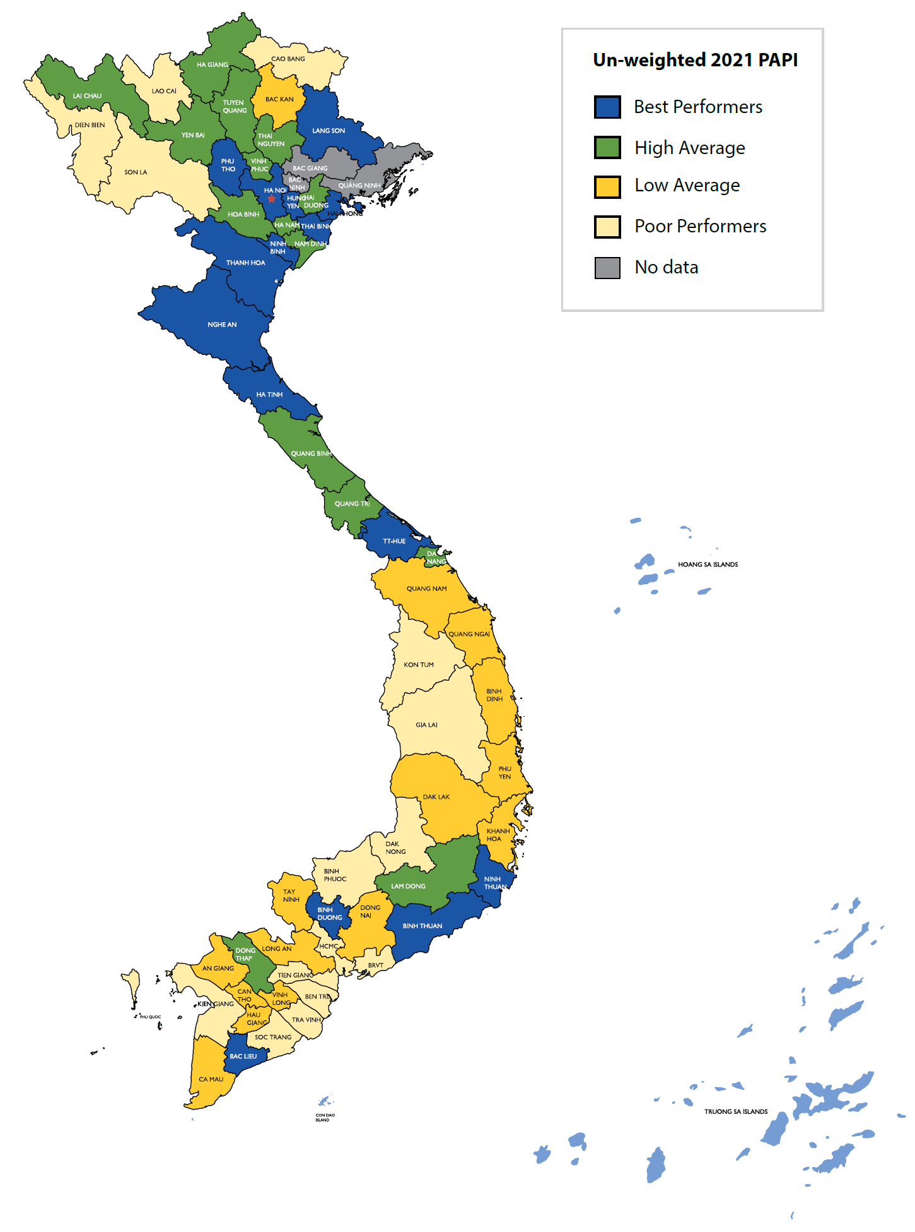
The 2021 PAPI Report also provides an overview of aggregate performance across provinces, calculated by adding up each province’s scores in the eight PAPI dimensions. This allows provinces to assess how they perform relative to other provinces with similar socio-economic and geographic endowments. Deeper dives into sub-dimension and indicator level findings are key for those provinces that wish to respond to their citizens’ expectations effectively. This need is especially critical to understand the impacts of the COVID-19 pandemic on governance and to help provinces prepare for future economic and health crises.
Figure 1: Provincial Performance in Governance and Public Administration by Quartiles, 2021
The analysis of 2021’s data shows that more better-performing provinces are found in the northern regions, as shown in Figure 1, in contrast to the Central Highlands, southcentral coastal and Mekong Delta provinces that appear to have fallen behind. Among the five centrally-governed municipalities, Ho Chi Minh City is in the lowest-performing quartile, may be a result of long-term lockdowns during the COVID-19 outbreak that impeded citizens’ access to local governments and public services. Compared to 2020’s findings, 30 provinces made improvements in performance in Public Service Delivery, Environmental Governance and E-governance. However, 30 provinces saw declines in dimensional scores of Participation at Local Levels, Transparency in Local Decision-making, Vertical Accountability and Control of Corruption in the Public Sector.
Overall, there was a wider difference in provincial performance in Public Service Delivery in 2021. However, declines in highest and lowest 2021 provincial scores were evident in Participation at Local Levels, Transparency in Local Decision-making, Vertical Accountability and Control of Corruption in the Public Sector.

The Vietnam Provincial Governance and Public Administration Performance Index (PAPI) is a policy monitoring tool that assesses citizen experiences and satisfaction with government performance at the national and sub-national levels in governance, public administration and public service delivery. Following the initial pilot in 2009 and a larger survey in 2010, the PAPI survey has been implemented nationwide each year since 2011. For the 2021 PAPI Report, 15,833 randomly selected citizens were surveyed. In total, 162,066 Vietnamese citizens nationwide have been directly interviewed for PAPI since 2009.
PAPI measures eight dimensions: participation at local levels, transparency, vertical accountability, control of corruption, public administrative procedures, public service delivery, environmental governance and e-government.
PAPI is the result of collaboration between the Centre for Community Support and Development Studies (CECODES), the Centre for Research and Training of the Viet Nam Fatherland Front (VFF-CRT), Real-Time Analytics and the United Nations Development Programme (UNDP).
During its 13 years in existence, PAPI has been generously funded by the Government of Spain from 2009 to 2010; the Swiss Agency for Cooperation and Development (SDC) from 2011 to 2017; the Department of Foreign Affairs and Trade (DFAT) of Australia from 2018 to 2025; the Embassy of Ireland from 2018 to 2022; and the United Nations and UNDP in Viet Nam since 2009.
The full 2021 PAPI Report and more in-depth analysis of the findings are available at: www.papi.org.vn
Scan the QR code to download the 2021 PAPI Report to your smartphone:

#PAPIvn #PAPI2021

For more information, contact:

Nguyen Viet Lan
UN Communications Team
Tel: (+84 4) 38 500 158
Mob: (+84) 91 4436 769
Email: nguyen.viet.lan@undp.org

