Fact Sheet 2: Issues of Concern in 2022 and the COVID-19 Recovery
The PAPI Report in 2022, as with previous years, continued its tradition of spotlighting the key issues of concern for citizens and taking a temperature check on households’ economic optimism. These insights were especially critical in 2022 as the national recovery from the COVID-19 pandemic gathered pace one year on from the unprecedented social and economic losses that Viet Nam, like other countries in the world, incurred as a result of the health crisis.
The findings are also important as they provide context to analyze the shifts in important PAPI scores and provide a snapshot of which key policy priorities the central and local governments should address in the following year from citizens’ perspectives.

Citizens’ Assessment of Household and National Economic Situations in 2022 amid the COVID-19 Recovery
Amid the national economic rebound, with growth returning to pre-pandemic levels in the wake of an historically bad third quarter in 2021 when lockdowns caused a dramatic decline in productivity, PAPI’s findings reveal this recovery is also being felt at household level.
In a notable turnaround, 11.4 percent of respondents saw their household economic situation as “poor or very poor” in 2022, down from 15.3 percent in 2021 at the height of the pandemic for Viet Nam after an internationally-acclaimed defense against the virus in 2020. Similarly, this optimism is also evident when viewing the economic picture through a national lens. After an all-time high of 19.8 percent of respondents assessed national economic conditions as “bad” in 2021, this percentage dropped to 6.1 percent in 2022. Respondents viewing the economy as “good” also rebounded from 46.7 percent in 2021 to 66.1 percent a year later.
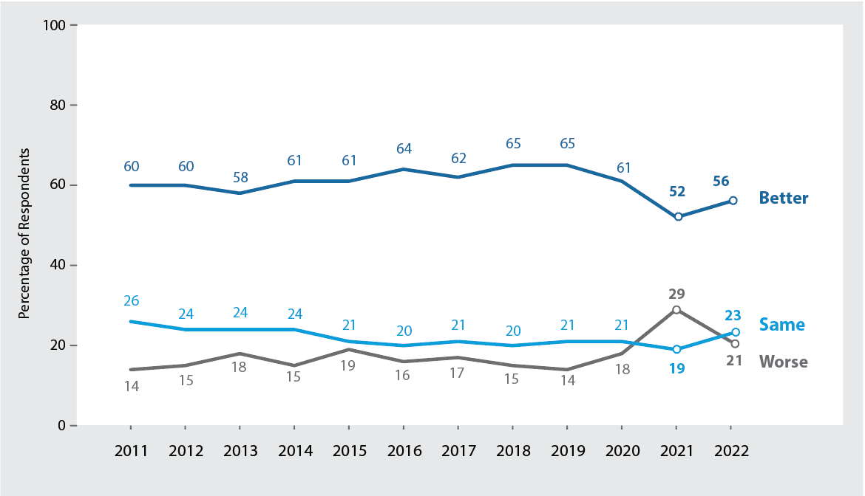
However, COVID-19 scarring is still visible, with other indicators pointing to economic conditions having yet to completely return to normal. While respondents were more likely to say their household economic conditions were better in 2022 (56 percent) than in 2021 (52 percent), aside from 2021, the results in 2022 were still the lowest since 2012 (see Figure 1). Similarly, those suggesting that their economic conditions were worse rose to their highest levels since 2011, except from 2021. These results show that, although economic conditions have improved since 2021, many respondents continue to feel the lingering pain from the health emergency.
Figure 1: Change in Household Economic Conditions in Past Three Years, 2011-2022
Drilling down further, this pessimism is particularly evident among ethnic minorities and women who perceive the economy in more negative terms given the higher prevalence of poverty among the former and vulnerable employment among the latter. Revealingly, women are about 5 percentage points less likely to say their current economic conditions are “good” compared to men, while minorities are about 9 percentage points less likely than the dominate Kinh ethnicity to say their economic situations are “good”.

Issue of Greatest Concern for Citizens in 2022
Each year, the PAPI survey asks citizens to assess the issue of greatest concern they think the national government should prioritize in the coming year. As with their assessment of household and national economic conditions, further evidence of the COVID-19 recovery is also visible in citizens’ selection of key issues of concern. Following the dramatic spike in health/health insurance as the most pressing national issue in 2021, it plummeted in 2022 (from 23.84 to 4.86 percent) to be overtaken by poverty/hunger (22.13 percent) – perennially at the top of the list since 2015, aside from pandemic-hit 2021 (see Figure 2).
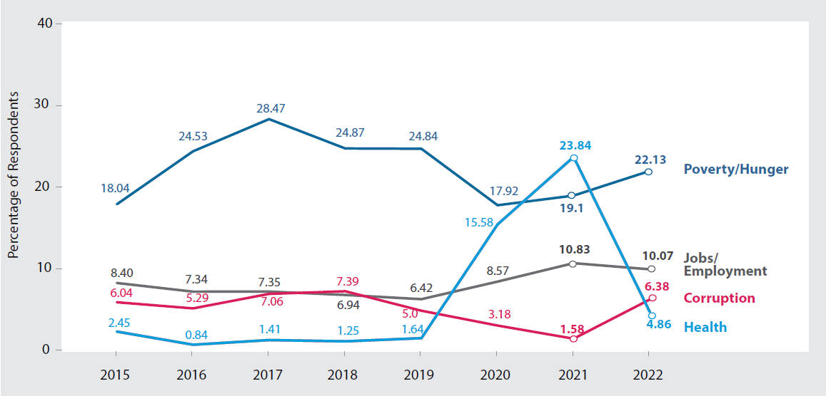
Figure 2: Changes in Selected Issues of Greatest Concern, 2015-2022
While this dramatic change could be expected with the decreasing profile of COVID-19 as a defining governance issue, there were other notable takeaways from 2022’s results.
Despite the high-profile national anti-corruption campaign, citizens expressed a greater level of concern with corruption in 2022 from a year earlier, with a 4.80 percent rise. This trend is consistent with PAPI’s findings in Dimension 4 ‘Control of Corruption in the Public Sector’, which saw the first publicly perceived downturn in government performance in tackling of corruption since 2015. One of the factors driving the declining numbers in this dimension was increased concern about nepotism in State employment, with land registration another area where citizens identified particularly high levels of opacity and corruption.
The quality of roads saw the second largest jump from 2021 (3.68 percent), to rank as the fourth most important issue in 2022, with economic growth/GDP second on the list and followed by jobs/employment.
Interestingly, citizens believe different levels of government should take the lead in addressing these wide-ranging issues of concern. The findings point to citizens viewing the national government as best placed to address economic issues and root out corruption. With corruption moving to the fore in PAPI 2022 as a hot button issue of concern, also in the context of the national crack-down, this does not mean that authorities at provincial or local levels are absolved from tackling this pervasive threat. Instead, Vietnamese respondents consider the national government as the most appropriate institution to deal with it. Turning to other levels of authority, road quality and land were key issues respondents associated with the provincial level, while at the village level local leaders were seen as more effective in dealing with practical demands, such as law and order./.

The Viet Nam Provincial Governance and Public Administration Performance Index (PAPI) is a policy monitoring tool that assesses citizen experiences and satisfaction with government performance at the national and sub-national levels in governance, public administration and public service delivery. Following the initial pilot in 2009 and a larger survey in 2010, the PAPI survey has been implemented nationwide each year since 2011. For the 2022 PAPI Report, 16,117 randomly selected citizens were surveyed. In total, 178,243 Vietnamese citizens nationwide have been directly interviewed for PAPI since 2009.
PAPI measures eight dimensions: participation at local levels, transparency, vertical accountability, control of corruption, public administrative procedures, public service delivery, environmental governance and e-government.
PAPI is the result of collaboration between the Centre for Community Support and Development Studies (CECODES), the Centre for Research and Training of the Viet Nam Fatherland Front (VFF-CRT), Real-Time Analytics and the United Nations Development Programme (UNDP).
During its 14 years in existence, PAPI has been generously funded by the Government of Spain from 2009 to 2010; the Swiss Agency for Cooperation and Development (SDC) from 2011 to 2017; the Department of Foreign Affairs and Trade (DFAT) of Australia from 2018 to 2025; the Embassy of Ireland from 2018 to 2023; and the UNDP in Viet Nam since 2009.
The full 2022 PAPI Report and more in-depth analysis of the findings are available at: www.papi.org.vn
Scan the QR code to download the 2022 PAPI Report to your smartphone:

#PAPIvn #PAPI2022

For more information, contact:

Nguyen Viet Lan
UN Communications Lead
Mob: (+84) 91 4436 769
Email: nguyen.viet.lan@undp.org

