Fact Sheet 3: Grassroots Democracy through Inclusive Elections
All Vietnamese citizens, from the age of 18 years, have a constitutional right to participate in the political, social and economic life of their country. This participation is critical for each person to exercise their democratic rights and do their part to help improve local governance.
That is why PAPI every year, since 2011, has measured the awareness of citizens to realize their right to political participation, how citizens participate in elections and local decision-making, as presented in PAPI Dimension 1: Participation at Local Levels.
To further bring citizens’ participation into sharp focus, PAPI in 2022 beamed a light onto the state of the nation’s fledgling grassroots democracy – a year critical to gain such insights.
With the full mobilization of the grassroots election apparatus and voting for village heads in all 63 of Viet Nam’s provinces in 2022, it was important to explore the reasons for an apparent decline in the competitiveness of elections, as indicated by the findings from PAPI surveys over time.
The year 2022 also witnessed important groundwork being laid for introduction of the Law on Grassroots Democracy Implementation in 2023, replacing the 2007 Ordinance on Grassroots Democracy Implementation at the Commune Level.
To help establish several important baselines for monitoring the related regulations of this "people-centered" law with the motto "people know, people discuss, people do, people monitor, people verify, people benefit", PAPI explored whether citizens’ voting choices reflect the political rights of the LGBTIQ+ community, people with disabilities (PwD) and people with diverse demographic backgrounds to reflect a vibrant and inclusive society.

2022 village elections and competitiveness over time
Village elections since 2002 are an important barometer of the health of grassroots democracy in Viet Nam, as they are a critical component of how laws governing political participation are implemented.
For this reason, the apparent wanning in competitiveness of village head elections according to PAPI data over time is of concern. 2022 was no different.
In these most recent elections, less than half (48 percent) of respondents reported their village elections had more than one candidate to vote for. In other words, in 28 provinces fewer than half of respondents said there was more than one name on the ballot sheet. In 2021 it had hit 45 percent – representing the two lowest years since PAPI started recording such trends. This is in stark contrast to 2011 and the 56 percent of respondents who had multiple voting options, which climbed to a highpoint of 58 percent in 2013 before largely trending down.
So, what is driving this apparent softening in competition? PAPI’s data suggest that one potential candidate is the changing role of village heads over time. Since the introduction of elections two decades ago, a key role of the village head is mobilizing additional resources for public works – especially critical in rural areas. However, with rapid economic growth and modernization, citizens may now be less responsible or willing to co-fund infrastructure as the local or central government has increasingly assumed this role.
If this is the case, the position may have declined in importance resulting in fewer candidates wanting to compete for the job. PAPI’s evidence supports this theory, as there has been a precipitous drop in the average number of respondents who paid voluntary contributions for local projects since 2015. This linkage is further underlined by a positive correlation between the two variables. It suggests that a 10-percentage point increase in the proportion of respondents paying voluntary contributions to local infrastructure projects equates to a nearly 5 percentage point increase in the proportion of respondents saying they have more than one village head election candidate.
At the same time, other burdens on village leaders remain, such as informing citizens about changes to new laws which particularly intensified during the recent COVID-19 pandemic where they were on the frontline hearing citizens’ concerns and passing them on to higher authorities. However, even with the lifting of restrictions in 2022, interactions remained at the highest level.

Inclusive Elections of Citizen Representatives
To ensure the diverse needs of society are met in the governance arena, it is critical that elected officials reflect the rich social fabric of Vietnamese society.
In this context, the 2022 PAPI survey explored whether there was a broader tolerance for Lesbian, Gay, Bisexual, Trans, Intersex and Queer (LGBTIQ+) and PwD candidates to be elected and participate in elected bodies in Viet Nam.
International research shows that increasing representation of historically marginalized groups is important for legitimizing them in the eyes of the broader public and the legitimacy of the political system in the view of this group.
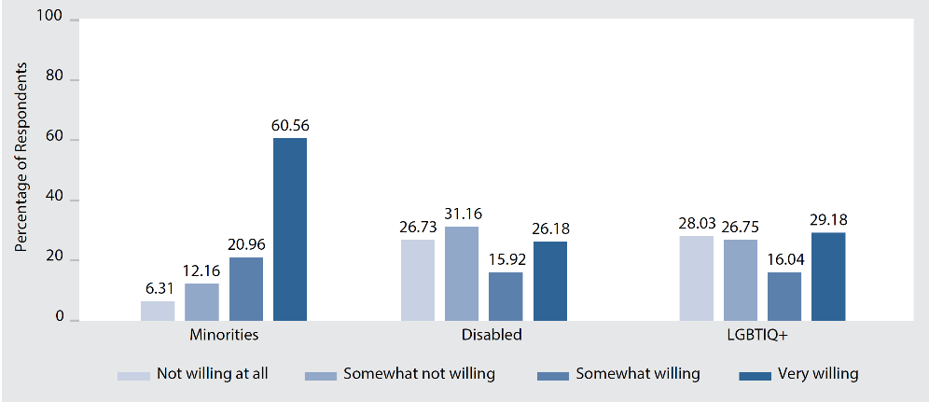
Despite increasing liberalization within society in recent years and Vietnamese Government showing interest in developing the legal framework for LGBTIQ+ rights, although gay/lesbian marriage not yet permitted by law, PAPI’s results spotlight a deep vein of stigmatization that still runs society. It found that openly lesbian or gay candidates running for National Assembly or village head positions will likely encounter strong negative bias. In a hypothetical matchup, lesbian candidates received 12 percent fewer votes than heterosexual male candidates, while gay men received about 8 percent fewer votes than heterosexual men candidates. While more work needs to be done to determine the source of bias against LGBTIQ+ candidates, the results suggest they will face strong headwinds in winning elections in the Vietnamese context, both at national and grassroots levels, unless stronger inclusive governance policies and advocacy are in place.
Figure 1: Respondents’ Willingness to Vote for Candidates with Diverse Backgrounds
PAPI 2022 also found that voters were more supportive of minority candidates, than those LGBTIQ+ and PwD across elected positions from central to grassroots levels. The 2022 survey results (see Figure 1: Respondents’ Willingness to Vote for Candidates with Diverse Backgrounds) show that, while 81.5 percent of total respondents showed a willingness to vote ethnic minority candidates to elected offices, about 45 percent said they were open to voting for LGBTIQ+ candidates and about 42 percent for candidates with a disability. However, there are reasons for optimism, as the solid foundation of voters already willing to vote for LGBTIQ+ and PwD will likely grow further with the introduction of inclusive election policies, as is the case for women in politics./.

The Viet Nam Provincial Governance and Public Administration Performance Index (PAPI) is a policy monitoring tool that assesses citizen experiences and satisfaction with government performance at the national and sub-national levels in governance, public administration and public service delivery. Following the initial pilot in 2009 and a larger survey in 2010, the PAPI survey has been implemented nationwide each year since 2011. For the 2022 PAPI Report, 16,117 randomly selected citizens were surveyed. In total, 178,243 Vietnamese citizens nationwide have been directly interviewed for PAPI since 2009.
PAPI measures eight dimensions: participation at local levels, transparency, vertical accountability, control of corruption, public administrative procedures, public service delivery, environmental governance and e-government.
PAPI is the result of collaboration between the Centre for Community Support and Development Studies (CECODES), the Centre for Research and Training of the Viet Nam Fatherland Front (VFF-CRT), Real-Time Analytics and the United Nations Development Programme (UNDP).
During its 14 years in existence, PAPI has been generously funded by the Government of Spain from 2009 to 2010; the Swiss Agency for Cooperation and Development (SDC) from 2011 to 2017; the Department of Foreign Affairs and Trade (DFAT) of Australia from 2018 to 2025; the Embassy of Ireland from 2018 to 2023; and the UNDP in Viet Nam since 2009.
The full 2022 PAPI Report and more in-depth analysis of the findings are available at: www.papi.org.vn
Scan the QR code to download the 2022 PAPI Report to your smartphone:

#PAPIvn #PAPI2022

For more information, contact:

Nguyen Viet Lan
UN Communications Lead
Mob: (+84) 91 4436 769
Email: nguyen.viet.lan@undp.org

