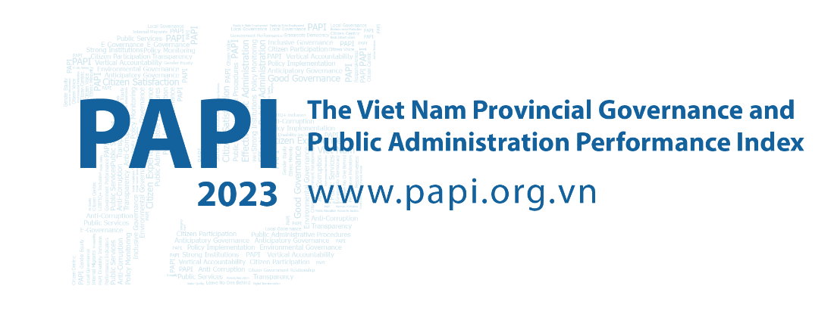

Fact Sheet #2: Issues of Concern in 2023
The PAPI Report in 2023 continued the tradition of previous years in taking the pulse of the national mood and spotlighting key issues of concern for citizens and households’ economic optimism during the year and over time. Importantly, PAPI also looks at how such issues evolve into drivers of migration within Viet Nam, with a focus in 2023 on the impacts of climate change-related disasters as motivations to relocate.
These findings are important as they provide context to analyze the shifts in important PAPI scores and deliver central and local governments with a snapshot of key policy priorities they should address in the following year and beyond from citizens’ perspectives.

Issue of Greatest Concern for Citizens in 2023
Each year, since 2015, the PAPI survey asks citizens to assess the issue of greatest concern they think the national government should prioritize in the coming year. Reflecting citizens’ increased anxiousness about the headwinds buffeting Viet Nam’s economy, in 2023 the top three issues to emerge were poverty/hunger (22.39 percent), followed by jobs/employment (12.79 percent) and economic growth (9.2 percent). Public services in the form of roads and education came next at 6.85 and 6.38 percent, respectively. Corruption ranked sixth at 5.25 percent, followed by income (5 percent), law and order (3.23 percent), land issues (2.73 percent) and health/insurance (2.47 percent). Interestingly, environmental pollution was outside the top 10.
Turning the spotlight onto changes in issues of greatest concern from 2022 to 2023, with the economy weighing heavily on the shoulders of citizens, jobs and employment saw the biggest rise by 2.7 percent followed by income (1.3 percent). Education (1.1 percent) was also a notable mover in the increased number of respondents earmarking it as an issue of concern from a year ago. Interestingly, amid the national anti-corruption campaign, corruption dropped by 1.1 percent from 2022 as also reflected in the improved 2023 performance of PAPI’s Dimension 4 (Control of Corruption in the Public Sector). This issue and trends are further explored in the 2023 PAPI Factsheet #4.
To drill down further onto citizens’ priorities over time from 2015, poverty has been omnipresent as a top concern, except for 2021 when health concerns spiked amid the COVID-19 emergency. Aside from health, the environment also saw a substantial fall since its peak in 2016 after the mass fish deaths off the coast of north-central Viet Nam that year.
An eye-catching trend, in keeping with the themes of the past two years, is a general increase in citizens’ concern with the economy over time. A deeper analysis shows that non-poverty related economic issues (such as income, jobs and economic-related policy) have constantly outgrown public service, governance and poverty since 2017 (23.11 percent) to become the most important cluster of concerns in 2023 (33.58 percent) identified by respondents as requiring urgent State attention. This general economic uncertainty is also mirrored in the consistent climb in concern about jobs/employment across 2015-2023 (8.40 to 12.79 percent).

Citizens’ Assessment of Household and National Economic Situations in 2023 and Over Time
Another insightful feature of PAPI is its annual request that respondents rate their current household economic situation, how it has changed compared to five years ago, and how they assess Viet Nam’s economic situation. These questions were particularly pertinent in 2023 in light of the darkening economic clouds rolling over Viet Nam as perceived by citizens and reported above.
The findings reveal that more Vietnamese citizens felt anxious about their household and the national economic situation in 2023 than ever before, aside from 2021 at the height of the pandemic.
Strikingly, the highest ever percentage of respondents (26 percent) recorded by PAPI said their household economic situation (in 2023) had become worse compared to five years ago, except for 2021. This pessimism also spread over Viet Nam’s economic situation, with fewer respondents in 2023 (54.4 percent, nearly 12 percent lower than in 2022) perceiving that the national economy was “good” and more respondents (13.6 percent) saying it was “bad” since 2018 when this question was first asked, aside from the 2021 outlier year. Wealth did not colour respondents’ views, as the poorest and richest individuals saw the national economy essentially the same way.
These economic concerns have key policy implications, including debate over early lumpsum withdrawals from Viet Nam’s Social Insurance Fund. PAPI results suggest that these reserves are important to citizens during difficult economic times. However, with an informal sector still evident in Viet Nam, PAPI in 2023 found that less than 30 percent of its respondents have access to social insurance.
In terms of factors hindering economic growth in 2023, one concern was electricity grid pressures with PAPI respondents reporting an increase in power outages from 63.5 percent in 2022 to 70.1 percent, commonly concentrated in provinces surrounding Ha Noi and the Mekong River Delta.

Drivers of Internal Migration in 2023
The economy was also a factor in PAPI’s annual tracking of migration drivers within Viet Nam, with better jobs (21.8 percent) the second biggest motivation in 2023 to migrate behind family reunions (40.68 percent), with the natural environment third (17.4 percent). The top three destinations in order of preference were Ho Chi Minh City, Ha Noi and Da Nang.
With Viet Nam one of the world’s most vulnerable countries to climate change impacts, PAPI in 2023 looked at how climate-related natural disasters may influence the migration decisions of citizens. A focus was the relationship between the Mekong River Delta and the climate-driven slow onset phenomena of salinization, which damages agricultural crops. Respondents from the delta, a major source of migrants to Ho Chi Minh City and surrounding industrialized provinces, reported that salinization had become an increasingly alarming problem, with more than twice as many respondents in these provinces from 2021 to 2022 saying they experienced salinization in their fields during the previous year. The number also increased by nearly a percentage point from 2022 to 2023. Flooding is another serious natural disaster threat, with double the percentage of citizens across Viet Nam experiencing it, from 6 percent in 2021 to more than 13 percent in 2022 and 2023, concentrated more in the central and northern regions./.

The Vietnam Provincial Governance and Public Administration Performance Index (PAPI) is a policy monitoring tool that assesses citizen experiences and satisfaction with government performance at the national and sub-national levels in governance, public administration and public service delivery. Following the initial pilot in 2009 and a larger survey in 2010, the PAPI survey has been implemented nationwide each year since 2011. For the 2023 PAPI Report, 19,536 randomly selected citizens were surveyed. In total, 197,779 Vietnamese citizens nationwide have been directly interviewed for PAPI since 2009.
PAPI measures eight dimensions: participation at local levels, transparency, vertical accountability, control of corruption, public administrative procedures, public service delivery, environmental governance and e-government.
PAPI is the result of collaboration between the Centre for Community Support and Development Studies (CECODES), Real-Time Analytics and the United Nations Development Programme (UNDP), with the support for fieldwork coordination from the Vietnam Fatherland Front’s central agencies and their provincial to grassroots chapters since 2009.
During its 15 years in existence, PAPI has been generously funded by the Government of Spain from 2009 to 2010; the Swiss Agency for Cooperation and Development (SDC) from 2011 to 2017; the Department of Foreign Affairs and Trade (DFAT) of Australia from 2018 to 2025; the Embassy of Ireland from 2018 to 2025; and the United Nations and UNDP in Viet Nam since 2009.
The full 2023 PAPI Report and more in-depth analysis of the findings are available at: www.papi.org.vn
Scan the QR code to download the 2023 PAPI Report to your smartphone:

#PAPIvn #PAPI2023

For more information, contact:

Nguyen Viet Lan
UN Communications Team
Tel: (+84 4) 38 500 158
Mob: (+84) 91 4436 769
Email: nguyen.viet.lan@undp.org

