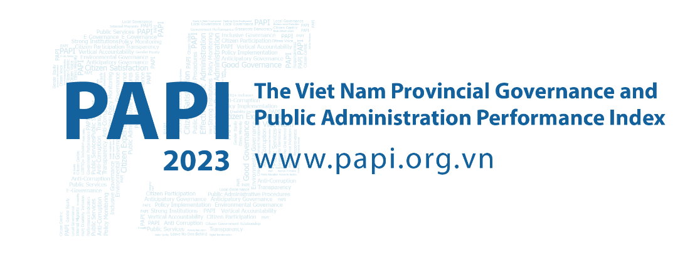

Fact Sheet #3: E-Governance Performance in 2023 – Digital Divide Looms Large
With E-Governance just one of two PAPI dimensions to show progress in 2023, it is important to click onto these findings to determine the true state of play of e-governance in Viet Nam considering the government’s recent push to expand digital government and citizenship.
With e-governance a force multiplier for better governance, it can help a province reduce corruption and expedite administrative procedures, while citizens can bypass cumbersome red tape and seamlessly interreact with government in a transparent manner.
That is why PAPI’s Dimension 8 has been gaining insights into how citizens have experienced access to the internet, e-government, and online public services since 2016. This has allowed PAPI to stay ahead of the curve and help inform the government’s subsequent launch of several initiatives in this domain to reduce bureaucratic discretion and corruption, improve transparency, and enhance government efficiency.
These endeavours include central and local government agencies digitalizing public administrative procedures and encouraging citizens to use central or provincial e-service portals. A monitoring system, the National E-Service Portal (NESP), was launched in 2019 and is now linked with all 63 provincial e-service portals to track local governments’ performance in delivering e-services. Importantly, Viet Nam aimed to bring half of administrative procedures online, complete and integrate an information system to manage ministry and provincial administrative procedures into the NESP and boost online payments for administrative procedures to 60 percent by the end of 2023.

Online to unlock to e-governance
Overall, the E-Governance dimension was a bright spot in PAPI 2023, with significant improvements compared to the previous three years from 2020. Two sources of encouragement were the sub-dimensions Access to the Internet (2.04 to 2.39 points) and enhanced Access to E-governance portals (0.4 to 0.47 points) from 2020 to 2023. In contrast, local governments need to better respond to citizens’ feedback and requests online, with the sub-dimension E-Responsiveness of Authorities remaining low and static.
Examining these findings further, nearly 80 percent of PAPI survey respondents in 2023 said they had access to the internet at home, more than double the percentage of 31 percent in 2016. Similarly, the percentage of respondents reading news from online sources almost tripled after eight years, to nearly 59 percent in 2023.
Despite these steps forward, does Viet Nam have a digital divide holding back inclusive access to e-government and e-services?

Mind the gap – digital divide emerges
A closer look at the findings reveals disparities in access to the internet by gender, living areas, ethnicity and migrant status. While men and women have increasing access to the internet, a persistent 5-10 percentage point gap has favoured men over the years, while ethnic minorities had a constant 10-20 percentage point lower level of access than the Kinh majority. Despite a convergence between rural and urban areas in 2023, permanent residents enjoyed about 5 percent greater access than non-permanent migrants in the 11 largest recipient provinces from 2021 to 2023.
This divide in varying degrees also cuts across ownership of personal computers and smartphones. While personal computer ownership favours Kinh as well as urban and permanent residents, it is critical to spotlight gaps in smartphone ownership as handheld devices offer greater portability and access to e-governance services. With 90.8 percent of respondents reporting they had smartphones, the largest ownership gap is between the Kinh majority (92.96 percent) and ethnic minorities (86.88 percent), with males and urban dwellers having slightly higher rates than peers.

Citizens slow to log-on to e-governance
The findings, overall, reveal that the pace of online services provision for citizen-centric administrative procedures has been much slower than internet development in Viet Nam. This is reflected in citizens’ engagement with Provincial E-Service Portals (PESPs), now available in all 63 provinces and linked with the umbrella National E-Service Portal (NESP) since 2022.
Out of 2023’s PAPI survey respondents, just 8.3 and 7.6 percent were NESP and PESP users, respectively. In terms of all-rounded e-services, among those doing administrative procedures online, 53.6 percent of NESP users could pay for the service online, while only 46.4 percent of PESP users could. These percentages fall short of the 2023 target of 60 percent as committed in the 2023 National Digital Transformation Action Plan.
Another reason for the low numbers of users was privacy concerns, as expressed by one-third of NESP and PESP users. This dovetails with findings from a 2022 United Nations Development Programme co-authored review, which revealed local governments’ substandard performance in personal privacy protection on government-citizen interaction interfaces.
For the first time, the PAPI survey in 2023 asked whether citizens could process applications for four public administrative procedures (government certification, land use rights certificates (LURCs), criminal records, and personal papers) through PESPs. It reveals that those applying for criminal records were most likely to submit applications through PESPs (28.7 percent), while only 11.9 percent applied for government certifications. LURCs and personal papers (such as birth, death and marriage certificates) were still largely paper-based.
While the gender and rural-urban divides in applicants’ use of PESPs were largely insignificant, starker differences emerge with ethnic minorities far less likely to submit applications through PESPs and finalize procedures in person at one-stop shops (OSSs). This underlines the need for e-services to reach ethnic minority citizens, who commonly have a more acute need because of the distances to travel from remote areas to physical OSSs. In terms of location of most PESP users, the five centrally-run municipalities and the Southeastern region were most common.
Shining a light onto the NESP, the national online OSS for citizens and businesses to access public administrative procedures, an increasing number of PAPI respondents (8.3 percent) in 2023 accessed it, almost doubling the percentage from 2022. Similarly, the percentage of those setting up NESP accounts also doubled in the past year (to 6.39 percent).
Of the PAPI respondent NESP users in 2023, the top three procedures with the largest percentage of users were application for new or renewed passports (16 percent), birth certificates (10.3 percent), and vehicle registration (10.1 percent). Nearly 69 percent said they could complete applications online, with new/renewed passports seeing the highest rate of online payments (90 percent).

Steps to realize e-governance’s potential
The PAPI findings in 2023 and over time underline the need for substantial improvements to the NESP, PESPs and government information portals to make them more accessible, user-friendly, convenient and inclusive for all citizen-users. A practical measure that central and provincial governments can take is to design and adopt a single-device approach to the online public service portals, so that users can access them from anywhere with their smartphones. In the meantime, traditional OSS should receive further investment to provide offline and online services for those who do not have smartphones or access to electricity yet.

The Vietnam Provincial Governance and Public Administration Performance Index (PAPI) is a policy monitoring tool that assesses citizen experiences and satisfaction with government performance at the national and sub-national levels in governance, public administration and public service delivery. Following the initial pilot in 2009 and a larger survey in 2010, the PAPI survey has been implemented nationwide each year since 2011. For the 2023 PAPI Report, 19,536 randomly selected citizens were surveyed. In total, 197,779 Vietnamese citizens nationwide have been directly interviewed for PAPI since 2009.
PAPI measures eight dimensions: participation at local levels, transparency, vertical accountability, control of corruption, public administrative procedures, public service delivery, environmental governance and e-government.
PAPI is the result of collaboration between the Centre for Community Support and Development Studies (CECODES), Real-Time Analytics and the United Nations Development Programme (UNDP), with the support for fieldwork coordination from the Vietnam Fatherland Front’s central agencies and their provincial to grassroots chapters since 2009.
During its 15 years in existence, PAPI has been generously funded by the Government of Spain from 2009 to 2010; the Swiss Agency for Cooperation and Development (SDC) from 2011 to 2017; the Department of Foreign Affairs and Trade (DFAT) of Australia from 2018 to 2025; the Embassy of Ireland from 2018 to 2025; and the United Nations and UNDP in Viet Nam since 2009.
The full 2023 PAPI Report and more in-depth analysis of the findings are available at: www.papi.org.vn
Scan the QR code to download the 2023 PAPI Report to your smartphone:

#PAPIvn #PAPI2023

For more information, contact:

Nguyen Viet Lan
UN Communications Team
Tel: (+84 4) 38 500 158
Mob: (+84) 91 4436 769
Email: nguyen.viet.lan@undp.org

