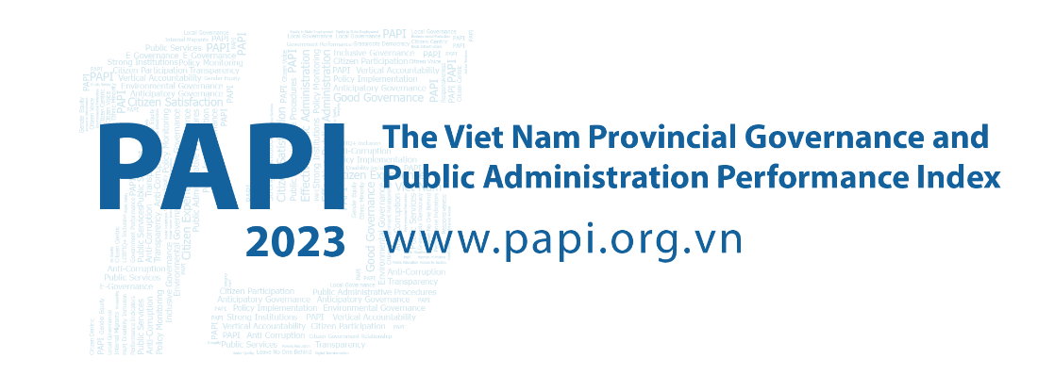

Fact Sheet #4: Control of Corruption in the Public Sector and Shining a Light on Transparency in Local Decision-making in 2023
PAPI was notable in 2023 for contrasting shifts in two of its highest profile dimensions for the year. With corruption possibly the issue of greatest concern from both the Party and citizens’ perspectives, the results of PAPI’s Dimension 4 (Control of Corruption in the Public Sector) and Transparency in Local Decision-making (Dimension 2) were eagerly awaited in 2023.

Their heightened profile is a result of the Party’s national anti-corruption campaign that has accelerated since the COVID-19 pandemic two years ago, yet the Party recently acknowledged that corruption was still a problem and it reflected poorly on the morality of public officials.

As key PAPI focus areas over the years, these two dimensions are vital enablers of a transparent, clean and effective functioning government. While Control of Corruption in the Public Sector is the dimension most strongly correlated with PAPI’s Overall Satisfaction with Government indicator from citizens’ perspectives, Dimension 2 measures transparency in local decision-making as it is critical to reducing corruption by exposing potential malfeasance.

Encouragingly, Control of Corruption in the Public Sector was one of only two dimensions in 2023 to show progress, albeit slightly from 6.71 to 6.77 points, compared to 2022. This optimism is also reflected in PAPI’s annual national issues of greatest concern to citizens, with corruption receding by the second largest percentage as a source of anxiety from 2022 to rank sixth overall in 2023 (1.1 and 5.25 percent, respectively). In contrast, Transparency in Local Decision-making comes under the spotlight as it showed the sharpest drop in performance in 2023 out of eight dimensions, from 5.28 to 5.16 points, compared to a year ago. Interestingly, these results have emerged despite 2023 being the first year of the 2022 Law on Grassroots Democracy Implementation coming into force.
While on the surface they appear to be two dimensions trending in opposite directions, a deep dive into the results paints a more complex picture that is important for policy-makers to view and inform national and provincial efforts to enhance transparency and tackle corruption in the governance arena.

One step forward in the national corruption fight
As one of two major bright spots in PAPI 2023, improvements were evident in three out of four sub-dimensions that make up Control of Corruption in the Public Sector. Limits on Corruption in Local Government, Limits on Corruption in Public Services and Equity in State Employment all took steps forward. However, to underline the complexity of the anti-corruption fight, there was regression in the percentage of respondents saying the national and province-level governments are serious about tackling corruption, as seen in the Willingness to Fight Corruption sub-dimension (see Figure 1).
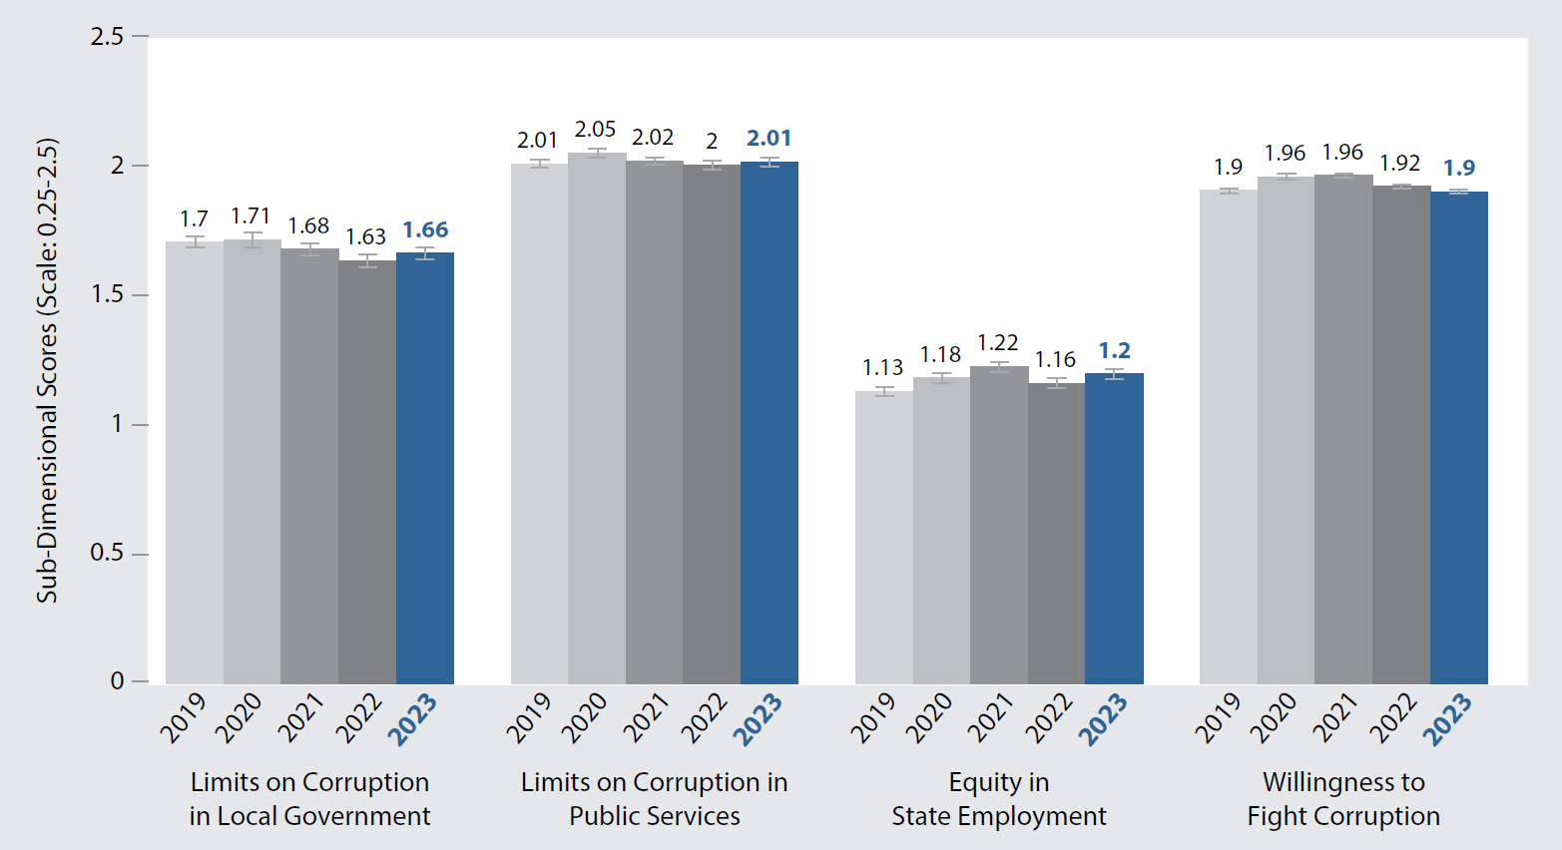
Figure 1: Changes in Control of Corruption in the Public Sector Sub-Dimensions, 2019-2023
A key PAPI focus in 2023 was exploring respondents’ perceptions of corruption issues. Strikingly, the proportion of respondents who believed that connections with authorized State persons are important to get a public office position (land registrars, justice officers, police officers, primary school teachers, and People’s Committee staff at commune level) has almost continuously dropped since 2016 when the campaign began. Still, despite the falls, concern is still high with nepotism as a success factor for the five positions, as reported by 56.17 to 62.53 percent of respondents.
Encouragingly, citizens’ perceptions of eight different types of corruption assessed by PAPI show improvement. While citizens believed that five types of corruption had declined over the past eight years, in 2023 more respondents (36.7 percent) perceived that informal payments were needed to secure State employment than in 2021.

But, one step back with a sharp fall in transparency
In contrast with the step forward in the battle against corruption, transparency in governance took a hit with Dimension 2 seeing the biggest drop in 2023. High performance in this dimension is an important component of weeding out corruption in the public sector, as citizens can only hold local officials accountable if they have access to accurate information.
Transparency also facilitates participatory governance as citizens are better able to offer feedback on budget and land use if they are informed about current government plans and activities. That is why PAPI measures transparency in local decision-making to inform policy-makers and practitioners of local governments’ performance in specific public-facing areas that citizens have a right to know, discuss and verify as provided in the 2016 Law on Access to Information and the 2022 Law on Grassroots Democracy Implementation.
Concerningly, compared to 2021, 23 provinces in 2023 saw significant year-on-year declines. Among 16 provinces in the Low quartile, the Mekong River Delta contributed eight, with three each from the Central Highlands and Southeastern regions.
The biggest source of dimensional score declines in 2023 was reduced transparency in commune budgets and expenditure. In simple terms, far fewer respondents reported that commune governments disclosed commune budget and expenditure worksheets for residents to be informed in the past 12 months. While 43 to 46 percent of respondents confirmed that worksheets were publicly available each year between 2018 and 2022, this tumbled to 38.94 in 2023, the lowest since 2016. These findings are important as open budgets can reduce corruption by increasing the likelihood that disparities in budget and actual expenditures can be identified. Making local government public officials accountable for State budgets and expenditure will help prevent embezzlement.
Similarly, transparency in poverty lists also provided downward pressure, part of a decline evident since 2019 when 30 percent of citizens said eligible households were missing from the list compared to 37.6 percent in 2023. This view is highest amongst those at the lowest end of the income scale./.

The Vietnam Provincial Governance and Public Administration Performance Index (PAPI) is a policy monitoring tool that assesses citizen experiences and satisfaction with government performance at the national and sub-national levels in governance, public administration and public service delivery. Following the initial pilot in 2009 and a larger survey in 2010, the PAPI survey has been implemented nationwide each year since 2011. For the 2023 PAPI Report, 19,536 randomly selected citizens were surveyed. In total, 197,779 Vietnamese citizens nationwide have been directly interviewed for PAPI since 2009.
PAPI measures eight dimensions: participation at local levels, transparency, vertical accountability, control of corruption, public administrative procedures, public service delivery, environmental governance and e-government.
PAPI is the result of collaboration between the Centre for Community Support and Development Studies (CECODES), Real-Time Analytics and the United Nations Development Programme (UNDP), with the support for fieldwork coordination from the Vietnam Fatherland Front’s central agencies and their provincial to grassroots chapters since 2009.
During its 15 years in existence, PAPI has been generously funded by the Government of Spain from 2009 to 2010; the Swiss Agency for Cooperation and Development (SDC) from 2011 to 2017; the Department of Foreign Affairs and Trade (DFAT) of Australia from 2018 to 2025; the Embassy of Ireland from 2018 to 2025; and the United Nations and UNDP in Viet Nam since 2009.
The full 2023 PAPI Report and more in-depth analysis of the findings are available at: www.papi.org.vn
Scan the QR code to download the 2023 PAPI Report to your smartphone:

#PAPIvn #PAPI2023

For more information, contact:

Nguyen Viet Lan
UN Communications Team
Tel: (+84 4) 38 500 158
Mob: (+84) 91 4436 769
Email: nguyen.viet.lan@undp.org

See Voice of Viet Nam (3 July 2023). Viet Nam shows strong resolve to root out corruption. Available at: https://english.vov.vn/en/politics/domestic/vietnam-shows-strong-resolve-to-root-out-corruption-post1030220.vov. Accessed on 10 January 2024.
See The People (29 December 2023). Chống tham nhũng: Cuộc chiến còn cam go. [Anti-corruption: An arduous battle]. Available at: https://nhandan.vn/chong-tham-nhung-cuoc-chien-con-cam-go-post789881.html. Accessed on 10 January 2024.

